Configuration – GL, Loan Management   
Bug Report

Afrida Rahman

Last Executed: 04/09/2024

Tested link: <http://10.11.204.171:8888/psb/f?p=106:LOGIN:10429315284102>:::::

|  |  |  |  |  |
| --- | --- | --- | --- | --- |
| **Module** | **Bug Issue Date** | **Total Num of Bugs** | **Bug Fixed** | **Not fixed** |
| GL Setup | 04/09/2024 | 2 | 0 | **2** |
| Loan Management | 04/09/2024 | 1 | 0 | **1** |

**Retest done. C-1 (08.09.2024)**

**Retest done. C-2 (09.09.2024) - solved**

**GL**

1. Have to add a "GL A/C No" column in GL List **- solved**

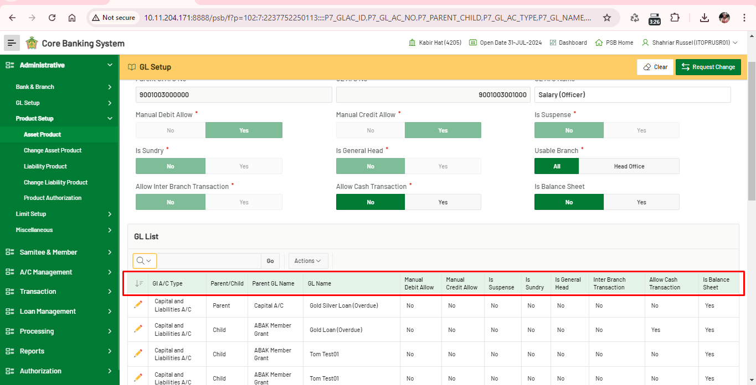

1. Error in approving the GL Change Request, in Authorization module. **- solved**

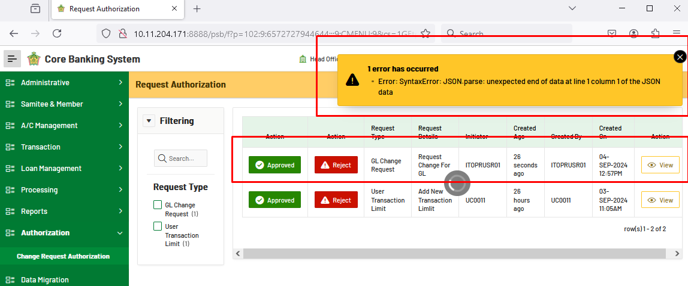

**Loan Management**

Sanction

1. Oracle error in Sanction request form in Authorization module. **- solved**

